Hoang Vo

1671058

**Lab #3**

**Task #1**: How many times was the market Up? Down?

The stock market was up 648 times and down 602 times.

> summary(Smarket)

Year Lag1 Lag2

Min. :2001 Min. :-4.922000 Min. :-4.922000

1st Qu.:2002 1st Qu.:-0.639500 1st Qu.:-0.639500

Median :2003 Median : 0.039000 Median : 0.039000

Mean :2003 Mean : 0.003834 Mean : 0.003919

3rd Qu.:2004 3rd Qu.: 0.596750 3rd Qu.: 0.596750

Max. :2005 Max. : 5.733000 Max. : 5.733000

Lag3 Lag4 Lag5

Min. :-4.922000 Min. :-4.922000 Min. :-4.92200

1st Qu.:-0.640000 1st Qu.:-0.640000 1st Qu.:-0.64000

Median : 0.038500 Median : 0.038500 Median : 0.03850

Mean : 0.001716 Mean : 0.001636 Mean : 0.00561

3rd Qu.: 0.596750 3rd Qu.: 0.596750 3rd Qu.: 0.59700

Max. : 5.733000 Max. : 5.733000 Max. : 5.73300

Volume Today Direction

Min. :0.3561 Min. :-4.922000 Down:602

1st Qu.:1.2574 1st Qu.:-0.639500 Up :648

Median :1.4229 Median : 0.038500

Mean :1.4783 Mean : 0.003138

3rd Qu.:1.6417 3rd Qu.: 0.596750

Max. :3.1525 Max. : 5.733000

**Task #2:** The smallest p-value here is associated with Lag1. How do we interpret its coeffcient estimate?

The coefficient estimate of Lag1 is -0.073074 => the direction of stock market has a negative insignificant relationship with Lag1. For each change in numerical value Lag1, the value of direction changes to opposite trend. With a unit increase of Lag1, the value of Direction will decrease with value that is 7% of the increase in Lag1.

**Task #3:** What is the predicted value? How do we interpret it?

> plot(c(0.5,-0.5,0.5,-0.5,0.5), type='l') # "Catch" the wave.

> predict(glm.fit, type="response", newdata = data.frame(Lag1 =0.5, Lag2 = -0.5,Lag3= 0.5, Lag4=-0.5, Lag5= 0.5,Volume=2))

1

0.5338269

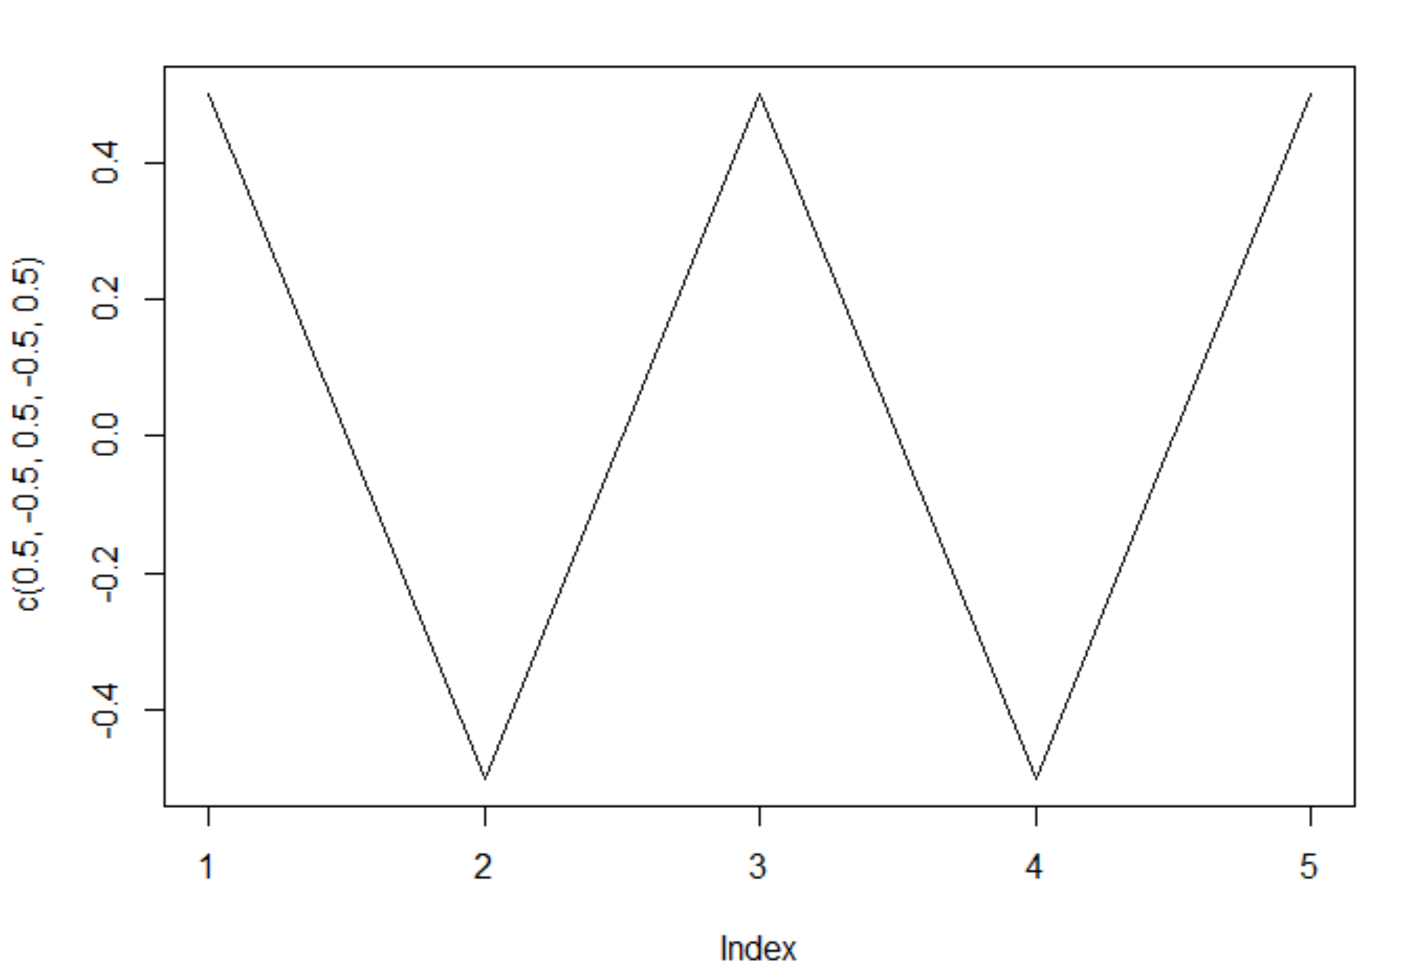

The predicted value:

1

0.5338269

The Y=1 is the category of going UP in stock market. There was 53% chance that the stock market would go up.

**Task #4:** Print the _rst 10 predictions for test data (_rst 10 elements of glm:probs.

> glm.probs

999 1000 1001 1002 1003

0.5282195 0.5156688 0.5226521 0.5138543 0.4983345

1004 1005 1006 1007 1008

0.5010912 0.5027703 0.5095680 0.5040112 0.5106408

**Task #5:** Print the resulting confusion matrix and the test error rate.

> table(glm.pred,Direction.2005)

Direction.2005

glm.pred Down Up

Down 77 97

Up 34 44

> mean(glm.pred == Direction.2005)

[1] 0.4801587

> glm.pred

[1] "Up" "Up" "Up" "Up" "Down" "Up" "Up" "Up" "Up" "Up" "Up" "Down" "Up" "Up"

[15] "Up" "Up" "Down" "Down" "Down" "Up" "Down" "Down" "Down" "Up" "Down" "Down" "Up" "Up"

[29] "Up" "Down" "Up" "Up" "Up" "Up" "Up" "Up" "Up" "Down" "Down" "Down" "Up" "Down"

[43] "Down" "Down" "Down" "Up" "Up" "Up" "Up" "Up" "Up" "Up" "Up" "Down" "Up" "Up"

[57] "Down" "Down" "Down" "Down" "Down" "Down" "Down" "Down" "Down" "Down" "Down" "Up" "Up" "Down"

[71] "Down" "Up" "Up" "Down" "Down" "Down" "Down" "Down" "Down" "Down" "Down" "Down" "Down" "Down"

[85] "Down" "Down" "Down" "Up" "Down" "Down" "Up" "Down" "Up" "Down" "Down" "Down" "Down" "Down"

[99] "Down" "Down" "Up" "Down" "Down" "Up" "Down" "Down" "Up" "Up" "Down" "Up" "Down" "Down"

[113] "Down" "Down" "Down" "Down" "Down" "Down" "Up" "Down" "Up" "Up" "Up" "Down" "Down" "Up"

[127] "Up" "Down" "Down" "Up" "Down" "Down" "Down" "Down" "Down" "Down" "Up" "Down" "Down" "Down"

[141] "Down" "Down" "Down" "Down" "Down" "Up" "Up" "Down" "Down" "Up" "Up" "Up" "Down" "Down"

[155] "Down" "Down" "Up" "Up" "Up" "Down" "Up" "Down" "Up" "Up" "Up" "Up" "Down" "Down"

[169] "Down" "Down" "Up" "Down" "Down" "Down" "Down" "Down" "Down" "Up" "Down" "Down" "Down" "Down"

[183] "Down" "Down" "Down" "Down" "Down" "Down" "Down" "Down" "Down" "Down" "Up" "Down" "Down" "Down"

[197] "Down" "Down" "Down" "Down" "Down" "Down" "Down" "Down" "Down" "Down" "Down" "Down" "Down" "Down"

[211] "Down" "Down" "Down" "Down" "Down" "Down" "Down" "Down" "Down" "Down" "Down" "Down" "Down" "Down"

[225] "Down" "Down" "Down" "Down" "Up" "Down" "Down" "Down" "Down" "Down" "Down" "Down" "Down" "Down"

[239] "Down" "Down" "Down" "Down" "Down" "Down" "Down" "Down" "Down" "Down" "Up" "Up" "Up" "Up"